**Proiectarea Circuitelor Integrate**

**Proiect: Algoritm de împărțire fără restaurare (numere pozitive)**

**Profesor coordonator : Sef lucr.dr.ing.**[**Tulbure Traian**](http://etc.unitbv.ro/~tulbure/)

**Student: Gheorghe Stefan**

**Specializarea: Electronica Aplicata**

**Anul de studiu: IV**

Cuprins

Specificatii de proiectare 3

Justificarea proiectarii 4

Descrierea in VHDL a circuitului 6

Layout-ul final generat in Alliance 13

# Specificatii de proiectare

|  |  |  |  |
| --- | --- | --- | --- |
| **Denumire port** | **Sens** | **Dim. [biți]** | **Semnificație** |
| ***op1*** | in | 8 | Primul operand |
| ***op2*** | in | 8 | Al doilea operand |
| ***cat*** | out | 8 | Catul impartirii |
| ***rest*** | out | 8 | Restul impartirii |
| ***start*** | in | 1 | Semnal pentru startul operației de înmulțire/împărțire |
| ***valid*** | out | 1 | Rezultat valid al operației de înmulțire/împărțire |
| ***reset*** | in | 1 | Reset |
| ***ck*** | in | 1 | Semnal de ceas |

**Algoritmul de impartire:**

- resetează P (n+1 biți)

- încarcă deîmpărțitul în A (n biți)

- încarcă împărțitorul în B (n biți)

- repeta de n ori

- dacă P este negativ (MSB=1) atunci

- deplasează cu o poziție stânga P (LSB P = MSB A)

- P <= P + B

altfel - deplasează cu o poziție stânga P (LSB P = MSB A)

- P <= P + (-B) - deplasează cu o poziție stânga A (LSB A = not MSB P)

- dacă P este negativ (MSB=1) atunci

- P <= P + B

- P conține REST

- A conține CÂT

# Justificarea proiectarii

Calea de control:

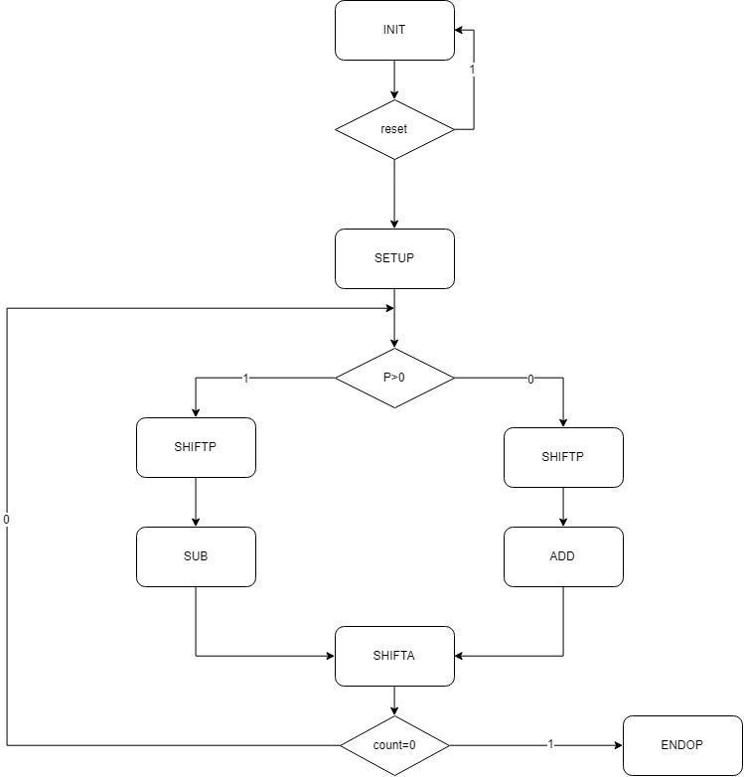

Cale de date

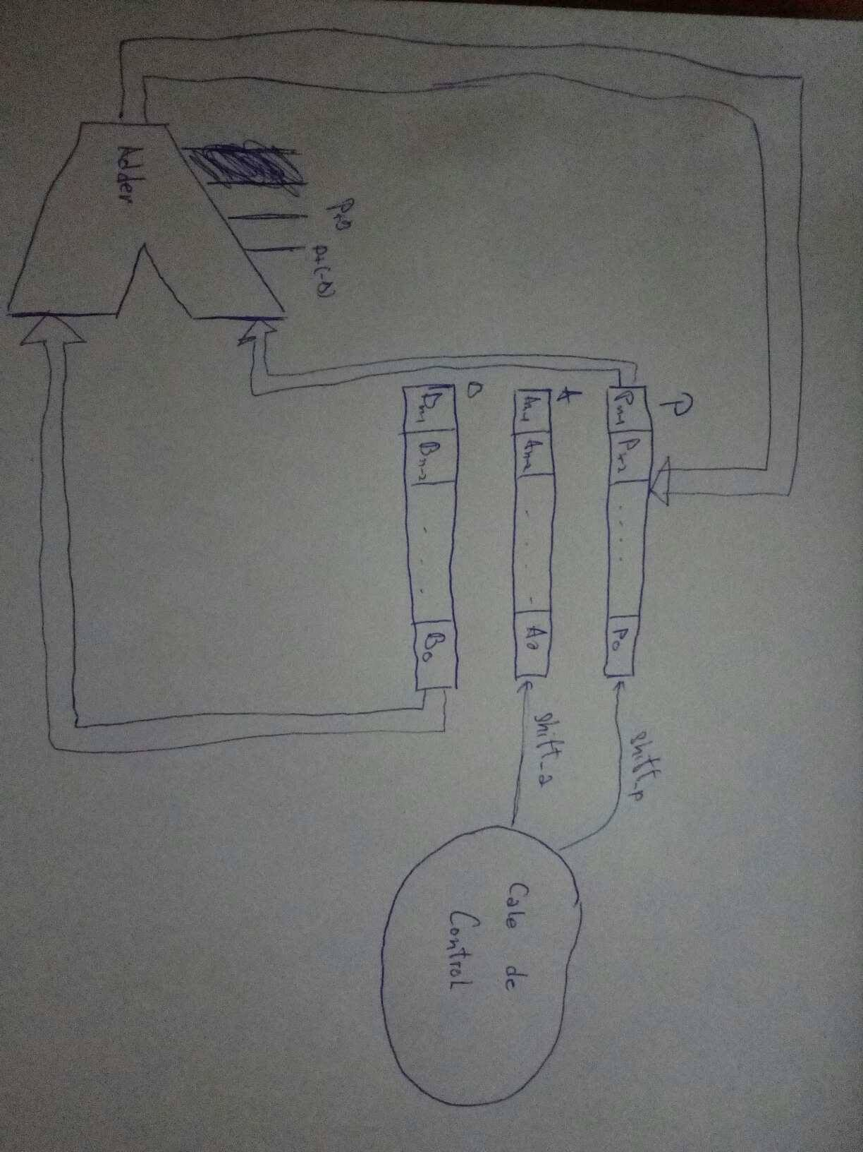

Schema Bloc

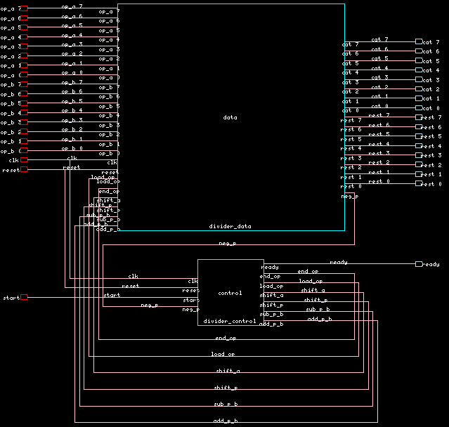

Semnale interne

|  |  |  |
| --- | --- | --- |
| **Denumire** | **Dimensiune[biti]** | **Semnificatie** |
| load_op | **1** | **Semnalul de incarcare a operanzilor** |
| end_op | **1** | **Semnalul de finalizare a operatiei** |
| shift_a | **1** | **Semnalul de deplasare a registrului a** |
| shift_p | **1** | **Semnalul de deplasare a registrului p** |
| sub_p_b | **1** | **Semnalul de scadere a registrului b din registrul p** |
| add_p_b | **1** | **Semnalul de adunare a registrului b cu registrul p** |
| neg_p | **1** | **Primul bit al registrului p** |

# Descrierea in VHDL a circuitului

Calea de control:

LIBRARY IEEE;

USE IEEE.std_logic_1164.ALL;

USE IEEE.std_logic_arith.ALL;

USE IEEE.std_logic_unsigned.ALL;

entity divider_control is

port ( clk : in std_logic;

reset : in std_logic;

start : in std_logic;

neg_p : in std_logic;

ready : out std_logic;

end_op : out std_logic;

load_op : out std_logic;

shift_a : out std_logic;

shift_p : out std_logic;

sub_p_b : out std_logic;

add_p_b : out std_logic

);

end divider_control;

architecture divider_control_arch of divider_control is

type stare is (INIT, SETUP, SHIFTP, SHIFTA, ENDOP, SUB, ADD);

signal curenta : stare;

signal urmatoare: stare;

signal valid : std_logic;

signal count : integer;

begin

CLC : process (reset, curenta, start, neg_p, count) begin

case curenta is

when INIT =>

if (reset = '0') then urmatoare <= INIT;

elsif (start = '1') then urmatoare <= SETUP;

else urmatoare <= INIT;

end if;

when SETUP =>

if (reset = '0') then urmatoare <= INIT;

else urmatoare <= SHIFTP;

end if;

when SHIFTP =>

if (reset = '0') then urmatoare <= INIT;

elsif (count = 0) then urmatoare <= ENDOP;

else urmatoare <= SUB;

end if;

when SUB =>

if (reset = '0') then urmatoare <= INIT;

else urmatoare <= SHIFTA;

end if;

when SHIFTA =>

if (reset = '0') then urmatoare <= INIT;

elsif (neg_p = '1') then urmatoare <= ADD;

elsif (count = 0) then urmatoare <= ENDOP;

else urmatoare <= SHIFTP;

end if;

when ADD =>

if (reset = '0') then urmatoare <= INIT;

elsif (count = 0) then urmatoare <= ENDOP;

else urmatoare <= SHIFTP;

end if;

when ENDOP =>

if (reset = '0') then urmatoare <= INIT;

else urmatoare <= INIT;

end if;

end case;

if (curenta = SETUP) then load_op <= '1';

else load_op <= '0';

end if;

if (curenta = SHIFTP) then shift_p <= '1';

else shift_p <= '0';

end if;

if (curenta = SUB) then sub_p_b <= '1';

else sub_p_b <= '0';

end if;

if (curenta = SHIFTA) then shift_a <= '1';

else shift_a <= '0';

end if;

if (curenta = ADD) then add_p_b <= '1';

else add_p_b <= '0';

end if;

if (curenta = ENDOP) then end_op <= '1';

else end_op <= '0';

end if;

end process CLC;

REG : process (clk) begin

if ((not clk'stable) and (clk = '1')) then

curenta <= urmatoare;

end if;

end process REG;

CONTOR : process (clk) begin

if(( not clk'STABLE ) and ( clk = '1' )) then

if (reset = '0') then count <= 0;

elsif (curenta = INIT) then count <= 8;

elsif (curenta = SHIFTP) then count <= count - 1;

end if;

end if;

end process CONTOR;

VALIDARE : process (clk) begin

if ((not clk'STABLE ) and (clk = '1')) then

if (reset = '0') then valid <= '0';

elsif (curenta = ENDOP) then valid <= '1';

elsif (curenta = INIT) then valid <='0';

end if;

end if;

end process VALIDARE;

ready <= valid;

end divider_control_arch;

Calea de date

LIBRARY IEEE;

USE IEEE.std_logic_1164.ALL;

USE IEEE.std_logic_arith.ALL;

USE IEEE.std_logic_unsigned.ALL;

entity divider_data is

port ( op_a : in std_logic_vector (7 downto 0);

op_b : in std_logic_vector (7 downto 0);

result : out std_logic_vector (15 downto 0);

rest : out std_logic_vector (7 downto 0);

clk : in std_logic;

reset : in std_logic;

load_op : in std_logic;

end_op : in std_logic;

shift_a : in std_logic;

shift_p : in std_logic;

sub_p_b : in std_logic;

add_p_b : in std_logic;

neg_p : out std_logic

);

end divider_data;

architecture divider_data_arch of divider_data is

signal a : std_logic_vector (7 downto 0);

signal b : std_logic_vector (7 downto 0);

signal p : std_logic_vector (7 downto 0);

signal r : std_logic_vector (15 downto 0);

begin

reg_a : process (clk) begin

if(( not clk'stable ) and ( clk = '1' )) then

if (reset = '0') then a <= "00000000";

elsif (load_op = '1') then a <= op_a;

elsif (shift_a = '1') then

a <= a(6 downto 0) & (not p(7));

end if;

end if;

end process reg_a;

reg_b : process (clk) begin

if(( not clk'STABLE ) and ( clk = '1' )) then

if (reset = '0') then b <= "00000000";

elsif (load_op = '1') then b <= op_b;

end if;

end if;

end process reg_b;

reg_p : process (clk) begin

if(( not clk'STABLE ) and ( clk = '1' )) then

if (reset = '0') then p <= "00000000";

elsif (load_op = '1') then p <= "00000000";

elsif (shift_p = '1') then p <= p(6 downto 0) & a(7);

elsif (sub_p_b = '1') then

p <= p - b;

elsif (add_p_b = '1') then p <= p + b;

end if;

end if;

end process reg_p;

reg_r : process (clk) begin

if(( not clk'STABLE ) and ( clk = '1' )) then

if (reset = '0') then r <= "00000000";

elsif (load_op = '1') then r <= "00000000";

elsif (end_op = '1') then

r(15 downto 8)<= a;

r(7 downto 0)<= p;

end if;

end if;

end process reg_r;

neg_p <= p(7);

result <= r;

end divider_data_arch;

Modulul top

LIBRARY IEEE;

USE IEEE.std_logic_1164.ALL;

entity divider is

port ( op_a : in std_logic_vector (7 downto 0);

op_b : in std_logic_vector (7 downto 0);

cat : out std_logic_vector (7 downto 0);

rest : out std_logic_vector (7 downto 0);

clk : in std_logic;

reset : in std_logic;

start : in std_logic;

ready : out std_logic

);

end divider;

architecture divider_arch of divider is

signal load_op : std_logic;

signal shift_a : std_logic;

signal shift_p : std_logic;

signal sub_p_b : std_logic;

signal add_p_b : std_logic;

signal end_op : std_logic;

signal neg_p : std_logic;

component divider_control

port ( clk : in std_logic;

reset : in std_logic;

start : in std_logic;

neg_p : in std_logic;

ready : out std_logic;

end_op : out std_logic;

load_op : out std_logic;

shift_a : out std_logic;

shift_p : out std_logic;

sub_p_b : out std_logic;

add_p_b : out std_logic );

end component;

component divider_data

port ( op_a : in std_logic_vector (7 downto 0);

op_b : in std_logic_vector (7 downto 0);

cat : out std_logic_vector (7 downto 0);

rest : out std_logic_vector (7 downto 0);

clk : in std_logic;

reset : in std_logic;

load_op : in std_logic;

end_op : in std_logic;

shift_a : in std_logic;

shift_p : in std_logic;

sub_p_b : in std_logic;

add_p_b : in std_logic;

neg_p : out std_logic );

end component;

begin

DATA : divider_data port map

( op_a => op_a,

op_b => op_b,

cat=>cat,

rest=>rest,

clk => clk,

reset => reset,

neg_p => neg_p,

end_op => end_op,

load_op => load_op,

shift_a => shift_a,

shift_p => shift_p,

sub_p_b => sub_p_b,

add_p_b => add_p_b );

CONTROL : divider_control port map

( clk => clk,

reset => reset,

start => start,

neg_p => neg_p,

ready => ready,

end_op => end_op,

load_op => load_op,

shift_a => shift_a,

shift_p => shift_p,

sub_p_b => sub_p_b,

add_p_b => add_p_b );

end divider_arch;

# Layout-ul final generat in Alliance

